Hackathon Project Phases Template that ensures students can complete it efficiently while covering all six phases. The template is structured to capture essential information without being time-consuming.

Hackathon Project Phases Template

Project Title:
Audio to Text transcription.

Team Name:
Phoenix

Team Members:
- Nakka Mani Sagar
- Darsi Rahul
- Dega Leela Ramana
- Gogula Rahul
- Losari Ganesh

Phase-1: Brainstorming & Ideation

Objective:
Many individuals and professionals struggle to efficiently and accurately transcribe audio content, such as lectures, meetings, podcasts, and interviews, into written text.This process is often time-consuming, labor-intensive, and prone to errors, resulting in wasted time, decreased productivity, and potential miscommunication.
1. Develop an accurate and efficient audio-to-text transcription app that can transcribe audio content in real-time or near real-time.
2. Improve accessibility for individuals with hearing impairments or language barriers.
3. Reduce transcription costs for individuals and organizations.
4. Enhance productivity by saving time and effort for users.

1.Problem Statement:
Many individuals and professionals struggle to efficiently and accurately transcribe audio content, such as lectures, meetings, podcasts, and interviews, into written text.This process is often time-consuming, labor-intensive, and prone to errors, resulting in wasted time, decreased productivity, and potential miscommunication.

2.Proposed Solution:
1. Develop an AI-powered audio-to-text transcription app that utilizes OpenAI's Whisper technology for accurate and efficient transcription.
2. Design a user-friendly interface that simplifies the transcription process and provides features such as customizable transcription settings, speaker identification, and audio editing.
3. Implement cloud-based storage to store transcriptions, allowing users to access them from anywhere.
4. Integrate with popular audio software to streamline the transcription process for users.
5. Develop a scalable and secure architecture to ensure high performance and protect user data.
3.Target Users:
1. Professionals: Journalists, researchers, podcasters, and lawyers who need to transcribe audio content for work.
2. Students: Individuals with hearing impairments or language barriers who need to access audio content for educational purposes.
3. Content creators: Podcasters, YouTubers, and social media influencers who need to transcribe audio content for their audiences.

4.Expected Outcome:
1. Accurate and efficient transcription: The app will provide accurate and efficient transcription, reducing the time and effort required for manual transcription.
2. Improved accessibility: The app will improve accessibility for individuals with hearing impairments or language barriers, enabling them to access audio content more easily.
3. Increased productivity: The app will increase productivity for professionals and content creators, allowing them to focus on high-value tasks rather than manual transcription.
4. Enhanced user experience: The app will provide a user-friendly interface and features that simplify the transcription process, enhancing the overall user experience.
5. Scalability and security: The app will be designed to scale with user demand and ensure high performance, while protecting user data with robust security measures.

Phase-2: Requirement Analysis

Objective:
The objective is to gather, analyze, and document the functional and non-functional requirements of the audio-to-text transcript app, ensuring that the solution meets the needs and expectations of the stakeholders.

Key Points:
- Technical Requirements:
1. Audio Input: Support for various audio formats (e.g., WAV, MP3, AAC) and sampling rates.
2. Transcription Engine: Integration with a reliable transcription engine (e.g., OpenAI's Whisper) for accurate transcription.
3. Text Output: Generation of formatted text output (e.g., JSON, XML, plain text).
4. User Interface: Development of a user-friendly interface for uploading audio files, displaying transcription results, and editing transcripts.
5. Security: Implementation of robust security measures to protect user data and ensure confidentiality.
6. Scalability: Design of a scalable architecture to handle increasing user demand and large audio files.
7. Compatibility: Development of a cross-platform app compatible with various operating systems (e.g., Windows, macOS, Linux) and devices (e.g., desktops, laptops, mobile devices).
- Functional Requirements:
1. Audio Input: Define the types of audio files and formats that the app will support.
2. Transcription: Specify the transcription technology and algorithms to be used.
3. Text Output: Determine the format and structure of the transcribed text.
4. User Interface: Define the user interface components, such as buttons, menus, and displays.
5. Audio Editing: Specify the audio editing features, such as trimming, cutting, and merging.

- Constraints & Challenges:
1. Audio Quality: Dependence on high-quality audio input for accurate transcription.
2. Transcription Accuracy: Limitations in transcription accuracy due to background noise, accents, or technical terms.
3. Computational Resources: Requirement for significant computational resources for transcription processing.
4. Data Storage: Need for secure and scalable data storage solutions for storing audio files and transcripts.
5. Regulatory Compliance: Adherence to regulatory requirements, such as GDPR, HIPAA, or CCPA, for handling sensitive user data.
6. Transcription Accuracy: Achieving high transcription accuracy, especially for audio files with background noise or technical terms.
7. Scalability and Performance: Ensuring the app's scalability and performance while handling large audio files and increasing user demand.
8. Security and Data Protection: Implementing robust security measures to protect user data and ensure confidentiality.
9. User Experience: Designing an intuitive and user-friendly interface for uploading audio files, displaying transcription results, and editing transcripts.
10. Integration with Transcription Engine: Integrating the app with a reliable transcription engine, such as OpenAI's Whisper, for accurate transcription.

Phase-3: Project Design

Objective:
The objective of this phase is to design a comprehensive system architecture, user flow, and UI design for the audio-to-text transcript app, ensuring a scalable, secure, and user- friendly solution.

Key Points:
- System Architecture Diagram:
- User Flow: 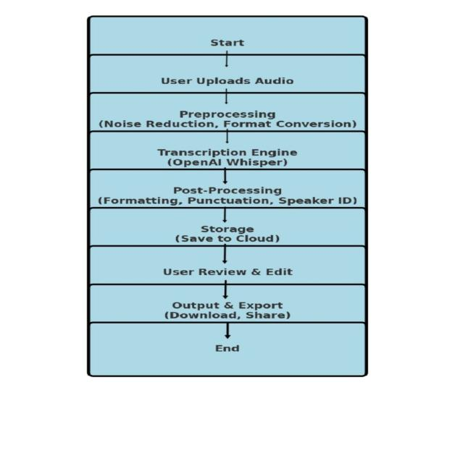
1. User Onboarding: User signs up for the app, providing necessary information (e.g., name, email, password).
2. Audio Upload: User uploads an audio file to the app.
3. Transcription: The app sends the audio file to the transcription engine for transcription.
4. Transcript Review: The app displays the transcription result to the user, allowing them to review and edit the transcript.
5. Transcript Save: The user saves the edited transcript, which is then stored in the transcript storage solution.
- UI/UX Considerations:
1. Home Screen
Clean UI with a "Start Transcription" button
Quick access to Settings and Saved Transcripts
2. Audio Upload
Drag & Drop area + Record Audio option
File format support: MP3, WAV, AAC
Upload progress bar
3. Transcription Page
Live transcription display
Speaker identification (if applicable)
Editing tools (highlight, correct words, timestamps)
Playback with synced text
4. Saved Transcriptions
List view with search & filter
Cloud storage integration (Google Drive, Dropbox)
5. Settings
Language selection
Font & Theme (Light/Dark Mode)
Security & Privacy settings
6. Export & Sharing
Save as Text, PDF, JSON
Direct sharing & Print option

Phase-4: Project Planning (Agile Methodologies)

Objective:
The objective is to plan and execute the development of the audio-to-text transcript app using Agile methodologies, ensuring a flexible and iterative approach to delivering a high-quality solution.

Key Points:
- Sprint Planning:
Sprint 1: Research and Planning (2 weeks)
- Conduct market research and analyze competitors
- Define the app's features and functionality
- Create a detailed project plan and timeline
- Identify and allocate tasks to team members

Sprint 2: Design and Prototyping (2 weeks)
- Design the app's user interface and user experience
- Create a functional prototype of the app
- Conduct user testing and gather feedback
- Refine the app's design and functionality

Sprint 3: Development (4 weeks)
- Develop the app's core features and functionality
- Integrate the transcription engine and audio storage solutions
- Implement security measures and access controls
- Conduct unit testing and integration testing

Sprint 4: Testing and Deployment (2 weeks)
- Conduct thorough testing of the app, including user acceptance testing
- Identify and fix any bugs or issues
- Deploy the app to production
- Conduct post-deployment testing and monitoring

- Task Allocation:

Team Member 1 (Project Manager)
- Conduct market research and analyze competitors
- Define the app's features and functionality
- Create a detailed project plan and timeline

Team Member 2 (UX/UI Designer)
- Design the app's user interface and user experience
- Create a functional prototype of the app
- Conduct user testing and gather feedback

Team Member 3 (Software Developer)
- Develop the app's core features and functionality
- Integrate the transcription engine and audio storage solutions
- Implement security measures and access controls

Team Member 4 (Quality Assurance Engineer)
- Conduct unit testing and integration testing
- Identify and fix any bugs or issues
- Conduct thorough testing of the app, including user acceptance testing

Timeline & Milestones:
Week 1-2: Research and Planning
- Conduct market research and analyze competitors
- Define the app's features and functionality
- Create a detailed project plan and timeline

Week 3-4: Design and Prototyping
- Design the app's user interface and user experience
- Create a functional prototype of the app
- Conduct user testing and gather feedback

Week 5-8: Development
- Develop the app's core features and functionality
- Integrate the transcription engine and audio storage solutions
- Implement security measures and access controls

Week 9-10: Testing and Deployment
- Conduct thorough testing of the app, including user acceptance testing
- Identify and fix any bugs or issues
- Deploy the app to production

Milestones:
Milestone 1: Research and Planning (Week 2)
- Complete market research and competitor analysis
- Define the app's features and functionality
- Create a detailed project plan and timeline

Milestone 2: Design and Prototyping (Week 4)
- Complete the app's user interface and user experience design
- Create a functional prototype of the app
- Conduct user testing and gather feedback

Milestone 3: Development (Week 8)
- Complete the development of the app's core features and functionality
- Integrate the transcription engine and audio storage solutions
- Implement security measures and access controls

Milestone 4: Testing and Deployment (Week 10)
- Complete thorough testing of the app, including user acceptance testing
- Identify and fix any bugs or issues
- Deploy the app to production

Phase-5: Project Development

Objective:
The objective is to develop a high-quality, scalable, and secure audio-to-text transcript app using a suitable technology stack and following best practices in software development.

Key Points:
- Technology Stack Used:
Frontend
1. React: A JavaScript library for building user interfaces.
2. Redux: A state management library for React applications.
3. Material-UI: A popular UI component library for React.
Backend
1. Node.js: A JavaScript runtime environment for building server-side applications.
2. Express.js: A popular Node.js framework for building web applications.
3. MongoDB: A NoSQL database for storing and retrieving data.
Transcription Engine
1. OpenAI's Whisper: A state-of-the-art automatic speech recognition (ASR) system.

- Development Process:
Agile Methodology
1. Scrum: A framework for managing and completing complex projects using iterative and incremental practices.
2. Sprints: Time-boxed iterations (typically 2-4 weeks) for developing and testing specific features
- Challenges & Fixes:
1. Transcription Accuracy: Ensuring high transcription accuracy, especially for audio files with background noise or technical terms.
2. Scalability and Performance: Handling large volumes of audio files and user traffic without compromising performance.
3. Security and Data Protection: Protecting user data and ensuring confidentiality, integrity, and availability.
Fixes:
1. Transcription Accuracy: Implementing noise reduction techniques, using multiple transcription engines, and conducting manual review and editing.
2. Scalability and Performance: Using cloud-based infrastructure (e.g., AWS), load balancing, and caching to ensure scalability and performance.
3. Security and Data Protection: Implementing encryption (e.g., SSL/TLS), access controls (e.g., authentication, authorization), and regular security audits and testing.

Phase-6: Functional & Performance Testing

Objective:
  - The objective of this phase is to ensure that the audio-to-text transcript app functions as expected, performs well under various loads, and is free from critical defects.

Key Points:
- Test Cases Executed:
1. User Registration: Test user registration, login, and password recovery.
2. Audio Upload: Test audio file upload, processing, and transcription.
3. Transcript Display: Test transcript display, formatting, and editing.
4. Search and Filter: Test search and filter functionality for transcripts.
5. User Profile: Test user profile management, including profile updates and deletion.

- Bug Fixes & Improvements:
1. Fixed: Audio file upload issue due to incorrect file type handling.
2. Fixed: Transcript display issue due to incorrect formatting.
3. Improved: Search functionality to include fuzzy matching and relevance ranking.
4. Improved: User profile management to include additional fields and validation.

- Final Validation:
1. Validation: Validated that all functional and performance test cases passed.
2. Validation: Validated that all bug fixes and improvements are properly implemented.
3. Validation: Validated that the app meets all non-functional requirements
4.Deployment (if applicable): (Hosting details or final demo link)

Final Submission
- Project Report Based on the templates
- Demo Video (3-5 Minutes)
- GitHub/Code Repository Link
https://github.com/Dega-Leela-Ramana/phoenix/upload/main
- Presentation

